Report_Code :

University of Chittagong

Department of Computer Science &

Engineering

8th Semester B.Sc. Engineering

Examination 2021

Course No.: CSE 800

Thesis Title: Tea Garden Automated Irrigation System & Mobile App using IoT.

Report_Code:

University of Chittagong

Department of Computer Science &

Engineering

8th Semester B.Sc. Engineering Examination 2021

Course No.: CSE 800

Thesis Title: Tea Garden Automated Irrigation System & Mobile App using IoT.

Student Name: Shariar Hasan

Student ID: 18701012

Session: 2017-2018

Hall: Shaheed Abdur Rab

Signature of Student:

...................................................

Submission Date: 01 August 2023

Approval for Submission

This thesis titled **‘Tea Garden Automated Irrigation System & Mobile App using IoT”**, by Shariar Hasan, Student ID: 18701012, Session / Batch: 2017- 2018, has been approved for submission to the Department of Computer Science and Engineering, University Of Chittagong, in partial fulfillment of the requirements for the 8th Semester BSc Engineering Examination 2021.

Dr. Mohammad Sanaullah Chowdhury

Professor, Department of Computer Science and Engineering

University Of Chittagong, Chittagong, Bangladesh.

Email: sana1691@gmail.com

Candidate Declaration

I, Shariar Hasan, declare that this research report is entitled ‘***IoT Tea Garden Automated Irrigation System & Mobile App using IoT***’ and the information presented in this document is my own. I confirm that:

* This research was done while I was a student of the degree of B.Sc. (Engineering) at the University of Chittagong.

* I have consulted the published work of other researchers.

* I have quoted from the work of other researchers; the source is always given. With the exception of such quotations, this is entirely my own work.

* I have acknowledged all main sources of help.

Signed: ---------------------------------------

Date: ------------------------------

Acknowledgment

At the very beginning, I wish to express my appreciation to the Almighty, for surrounding me with such outstanding individuals and, in particular, for this tremendous achievement.

I would like to express my heartfelt gratitude to my thesis supervisor, **Dr. Mohammad Sanaullah Chowdhury**, for his unconditional support, assistance, inspiration, and capable leadership during his supervision. His vast amount of information and practical ideas in the field of computer vision have enabled me to deal with large datasets as well as cutting-edge theories and methodologies. He has always been an excellent mentor to a newcomer like myself, and his encouragement and constructive criticism at every level of this thesis have only strengthened and instilled confidence in me to complete the research effectively. I owe it to myself to have this experience.

I would also like to express my gratitude to all of my professors and friends for their motivation and help throughout the project. For their intellectual support and encouragement, I am grateful to my parents.

ABSTRACT

A significant supply of water is essential for agriculture. Additionally, the demand for water resources grows along with the consumption of food. On the other hand, various crops need different amounts of water. Thus, manually watering crops often results in crop damage. In order to prevent excessive irrigation must be avoided as a way to prevent water waste and protect the crop from rotting. This problem may be resolved in a number of ways. The best course of action is to automate the system, nevertheless. The purpose of this automated system is to protect the water and energy resources. It keeps an eye on the action and gauges the water level both manually and automatically. Agriculture hasn't been able to produce enough crops to keep up with population growth because of the dynamic weather fluctuations. The fields are often irrigated using channel systems, which give regular water injections but offer little insight into their water level. This kind of irrigation is detrimental to crop growth and output since many crops are sensitive to the amount of water in the soil.

Chapter 01: Introduction 9

1.1 Background 11

1.2 Motivation 12

1.3 Objectives 13

Chapter 02: Literature Review 14

Chapter 03: Methodology 16

3.1 Problem Statement 16

3.2 Proposed System 17

3.2 Necessary Equipment 19

The Systems Arduino 20

1.1.1 Relays (Motors Controller) 20

Data Processing 20

Implementation 21

Hardware 21

Software and Code 22

1.1.2 Online Cloud Server(ThingSpeak) 22

Result 22

Expected Result 25

Conclusion 26

A 27

Code 27

B 31

Implementation images 31

**List of Figures**

|  |  |  |
| --- | --- | --- |
| 1 | Irrigation System With Sensors And Cloud Storage |  |
| 2 | Irrigation Control System |  |
| 3 | Flow chart of Automated irrigation System |  |
| 4 | Irrigation Control System Implementation |  |
| 5 | The Output in The serial monitor in Arduino IDE |  |
| 6 | The collected data Graph (temperature and humidity) |  |
| 7 | The collected data Graph (temperature and humidity) |  |
| 8 | The collected data Graph (Moisture) |  |
| 9 | The collected data Graph (Water level) |  |
| 10 | Main Controller |  |
| 11 | Sensors |  |
| 12 | WiFi Module |  |
| 13 | WIFI SIM800 Module |  |
| 14 | Motor and Relay |  |

# 

# Chapter 01: Introduction

Agriculture is the backbone of many economies, and maintaining proper water management is vital for sustained agricultural development. In recent years, the integration of Internet of Things (IoT) technology with agriculture has changed conventional agricultural operations. IoT-based smart irrigation systems have emerged as viable solutions to manage water shortage concerns and boost water efficiency in agriculture.

This research investigates the creation and deployment of an IoT-based smart irrigation system intended exclusively for tea plantations. Tea farming is an important economic activity in diverse places, and controlling water consumption is vital for tea plant health and output. The suggested smart irrigation system intends to automate irrigation operations, decreasing human involvement, and boosting water conservation.

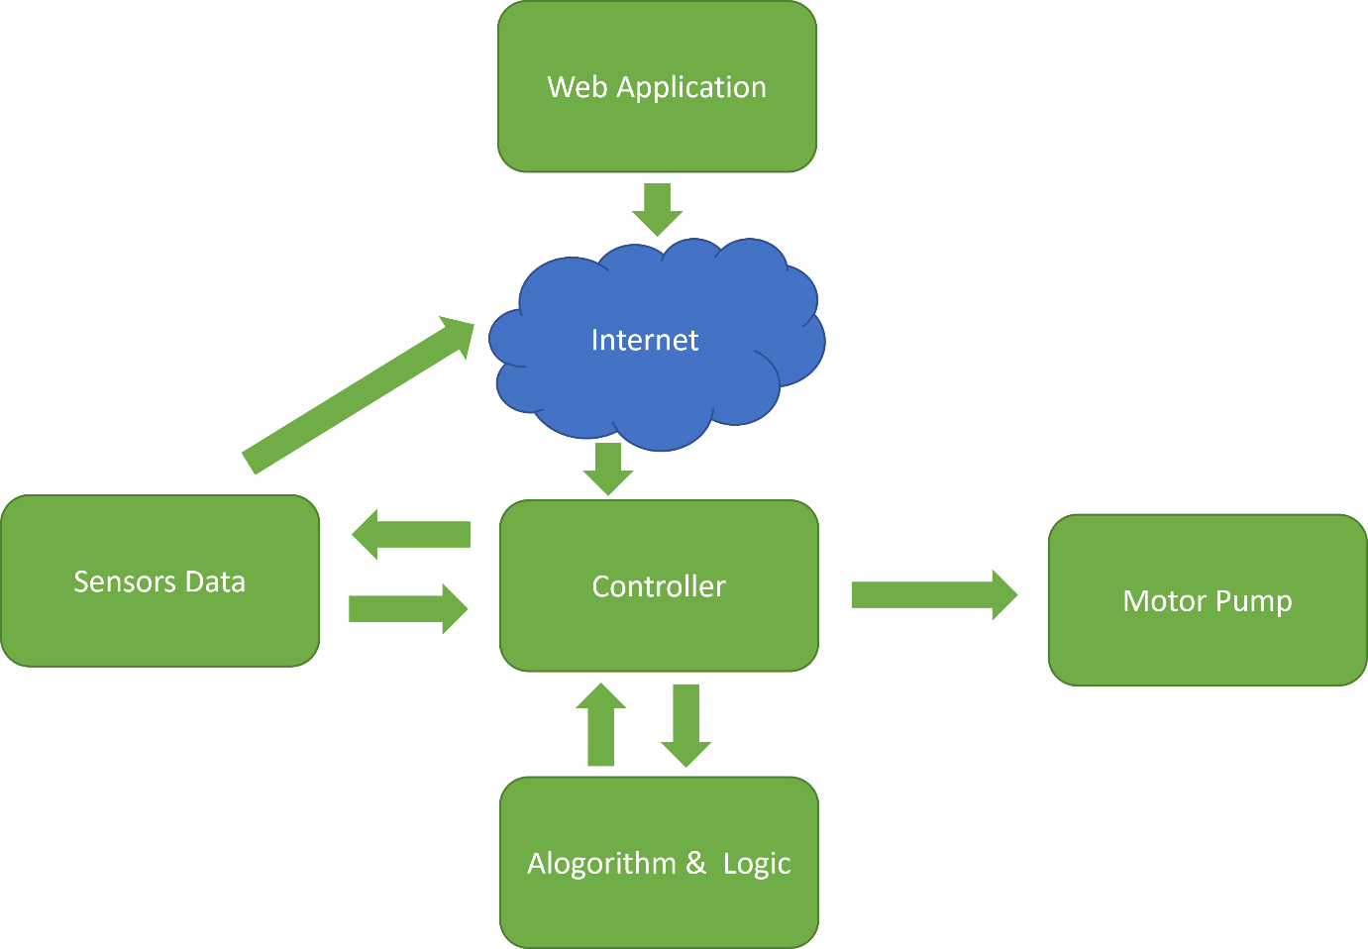

Figure 1: Irrigation System with Sensors and Cloud Storage.

The system employs NodeMCU 8266 microcontrollers to gather real-time data from soil moisture sensors and rain sensors. These sensors give vital insights into soil conditions and precipitation levels, allowing informed decision-making for irrigation. By utilizing sensor data and IoT technologies, the system can automatically calculate when and how much water is necessary for effective tea plant irrigation. A crucial aspect of the smart irrigation system is its Wi-Fi connection, enabling remote monitoring and management. Tea producers may examine the system's status and alter irrigation parameters using a user-friendly smartphone application. This remote management tool gives ease and flexibility, allowing farmers to effectively manage their tea plantations from a distance.

Ultimately, the IoT-based smart watering system for tea gardens is a step towards sustainable agricultural techniques. By using IoT technology, tea producers may optimize water consumption, boost crop yields, and contribute to the protection of vital water resources. The initiative coincides with the greater objective of encouraging eco-friendly alternatives to manage water constraint in the agriculture sector.

## 1.1 Background

The need for water in agriculture is great. The demand for water resources is increasing along with the expansion in food consumption. Different crops, however, have different water needs. As a result, manually watering crops often causes crop damage. It's important to avoid overwatering in order to minimize water loss and prevent the crop from rotting. To solve this problem, there are several strategies. The greatest option is to automate the system. This automated system's main objective is to safeguard the water and energy resources. Both manually and automatically, it gauges the water level while keeping an eye on the action. A lack of agricultural production to keep up with population growth is a result of the unpredictable weather patterns. Channel irrigation systems are often used to irrigate the fields; however, they only provide intermittent water injections and limited insight into the water level in the fields. This kind of irrigation has an adverse impact on crop growth and output since many crops are especially sensitive to the amount of water in the ground.

Due to water restrictions and unforeseen weather patterns, the agricultural sector has faced serious issues in recent years. Intelligent irrigation systems have come to be thought of as a potential solution to these problems. To monitor and manage irrigation operations more efficiently, these systems make use of Internet of Things (IoT) technology. The goal of the present study is to design an intelligent irrigation system that is specifically tailored for tea gardens.

## 1.2 Motivation

In many areas, tea growing is a significant economic activity. Keeping the soil at the ideal moisture level and reacting to rainfall are important aspects that have a direct influence on the health and productivity of tea plants. Traditional irrigation techniques often result in water waste and decreased output because they use too much water and distribute it unevenly. The suggested smart irrigation system uses IoT technology to improve water efficiency, reduce human involvement, and guarantee the tea plantations' sustainable development.

The necessity to solve urgent issues facing the agriculture industry is what drove the development of an IoT-based smart irrigation system. Economy-supporting agriculture provides food and raw materials to companies across the globe. However, the industry is dealing with a number of intricate problems that endanger its viability and production.

## 1.3 Objectives

The creation and implementation of an IoT-based smart irrigation system for tea gardens is the main goal of this project. The system will gather data on soil moisture and rainfall using NodeMCU 8266 microcontrollers, allowing automatic water supply control for tea plants. The project's precise goals are as follows:

* To monitor soil moisture levels in real-time, provide a trustworthy soil moisture sensor interface.
* Integrate rain sensors to track precipitation and determine if irrigation is necessary.
* To interpret sensor data and make wise judgments, create and program the NodeMCU 8266.
* Use a motor control system to automate irrigation depending on rainfall and soil moisture levels.
* To allow remote irrigation system monitoring and control, establish a Wi-Fi connection.
* Give farmers a simple way to utilize a mobile application to access and communicate with the system.
* Analyze the smart irrigation system's effectiveness and its effects on water saving and tea garden output.

# Chapter 02: Literature Review

[1] "**IoT-based smart crop-field monitoring and automation irrigation system**" by **R. N. Rao** and **B. Sridhar** **(2018)**:

An IoT-based smart irrigation system for agriculture fields is presented in the study. It makes use of sensors to keep track of a number of variables, including temperature and soil moisture. Through IoT technology, the gathered data is sent to a central control system. Using the sensor data, the system then automates the irrigation process to provide the best possible water use for crop growth.

[2]"**IoT-based smart irrigation system**" by **S. Rawal**, published in **2017**:

In order to improve water efficiency in agriculture, this study offers a smart irrigation system based on the Internet of Things. The system uses sensors to measure soil moisture to keep track of soil conditions, and it uses the cloud to store and analyze data. Through a smartphone application, the farmer may remotely operate the irrigation system, allowing effective water management.

[3] "**Intelligent irrigation system an IoT-based approach**" by **M. N. Rajkumar, S. Abinaya, and V. V. Kumar (2017)**:

The study introduces an automated watering system that makes use of IoT technologies. Real-time data are gathered by soil moisture sensors, and an algorithm is used by the system to evaluate the data and choose the best watering plan. The suggested strategy attempts to increase agricultural productivity and optimize water use.

[4] "**Automated irrigation system-IoT-based approach**" by **D. Mishra, A. Khan, R. Tiwari, and S. Upadhay (2018)**:

This study suggests an Internet of Things (IoT)-based automatic irrigation system that uses sensors to monitor soil temperature and moisture. A cloud server receives the gathered data and processes and analyzes it. In order to ensure effective water distribution for crops, the system then initiates the irrigation process based on predetermined criteria.

[5] "**IoT-based smart irrigation monitoring and controlling system**" by **S. B. Saraf and D. H. Gawali (2017)**:

An IoT-based smart irrigation system with monitoring and control features is presented in the study. Sensors that measure the temperature and moisture of the soil collect information, and the watering schedule is changed as a result. Through a web application or smartphone app, the farmer may remotely access the system, providing real-time administration and monitoring.

[6] "**IoT-based autonomous percipient irrigation system using Raspberry Pi**" by **A. Imteaj, T. Rahman, M. K. Hossain, and S. Zaman (2016)**:

This study suggests a Raspberry Pi-based, Internet of Things-based autonomous watering system. A Raspberry Pi controller and soil moisture sensors are used in the system to automate watering depending on the state of the soil. The technology attempts to cut down on water waste and increase agriculture's water consumption effectiveness.

# Chapter 03: Methodology

The main purpose of this project is building an automated system that controls the motors for irrigation of the field. Our proposed system contains multiple sensor devices (soil moisture sensor, rain sensor) and controlling techniques. We have discussed here about our system in details in the following subsections-

## 3.1 Problem Statement

The fundamental challenge addressed in this project is the need to decrease the excessive use of fresh water in conventional irrigation systems while simultaneously automating the whole irrigation process using a cost-effective method . The existing irrigation techniques generally lead to inefficient water use, with no association between excessive water usage and enhanced agricultural yields. The key to optimizing agricultural output depends in the exact and effective exploitation of water resources.

The project intends to design a smart irrigation system that optimizes water consumption and boosts agricultural production by automating the irrigation process. The system should allow farmers to select between human intervention and completely automated operation, providing flexibility and ease in controlling the irrigation process. By incorporating automation, the system can decrease water loss and enhance sustainable agriculture practices.

The effective completion of this project will help to water conservation efforts in agriculture, enhance crop output, and encourage efficient resource management. The smart irrigation system's cost-effectiveness and automation capabilities are vital in allowing farmers to embrace sustainable practices, lowering their ecological imprint, and assuring long-term agricultural resilience.

## 3.2 Proposed System

Water constraint is causing a lot of challenges in the agriculture area these days. Smart irrigation technology has been introduced to help farmers in conquering their challenges. Various sensors are coupled to the NodeMCU 8266 model in this system, including soil moisture, and rain sensors. The model is also equipped with a Wi-Fi connection in built. It is connected to internet server by WIFI and the data are uploaded to the Blynk server, as a result we can observe our field and also administer the system using mobile app from keeping distance from the system. The NodeMCU 8266 is coupled to relay which is later connected to the motor and light, respectively. The pump will be automatically turned ON/OFF by the relay circuit if the measured value exceeds the threshold values stated in the program according to the written logic. The relay circuit is attached to the drive circuit, which helps to modify the voltage. Through the WIFI module, the farmer will be alerted of the current field status, which will also be updated on the web page. The farmer may get information on the state of the field at any moment using this technique. Machine learning is applied for evaluating the received data and saving our anticipated value for further comparison. In the future, some machine learning approaches directly build judgements from the analysis of the obtained data maintained in the storage or cloud and the conclusions will be given to the relay module. Using WIFI technology will warn our farmers through SMS via mobile. The spectator may examine the recent conditions of the field. If any problem occurs, user will be notified by the system via application software. All type of data collected the sensors and after analyzing the obtained data, the processed report will be uploaded into the cloud and we may see the reports using application software installed in mobile or computer.

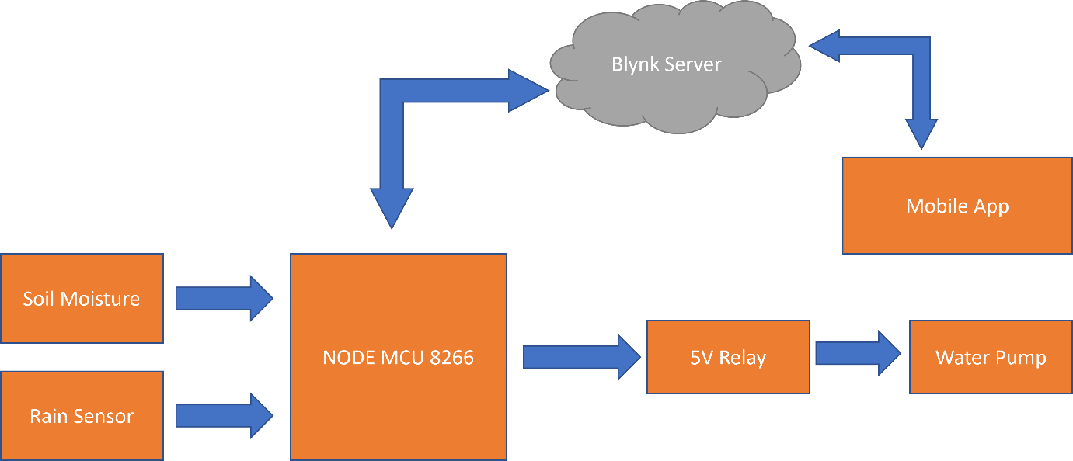

Figure Irrigation Control System.

How our system will be controlled and monitored from the collected data and how will our system work are described in the following flowchart:

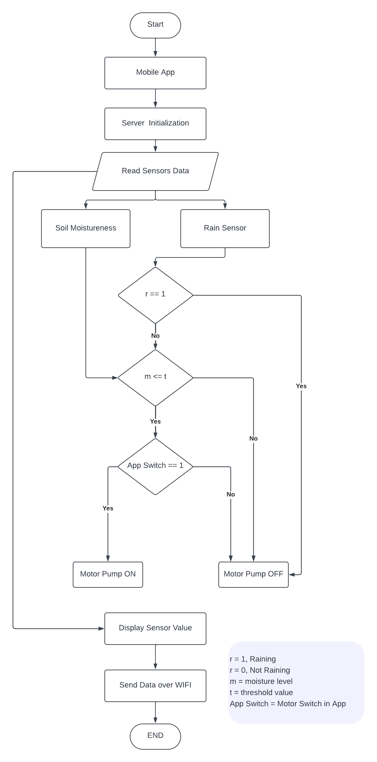

Figure Flow chart of Automated irrigation System

## 3.3 Block Diagram

The block diagram of the project is illustrated below:

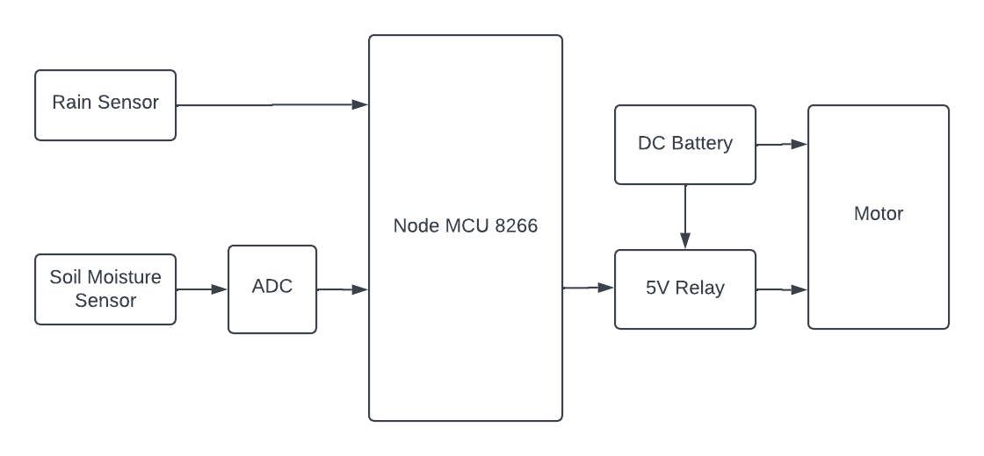

Figure Block Diagram of the project

## 3.4 Necessary Equipment

A sensor is an electronic device, component, or module that detects events or changes in its environment and relays the information to other electronics, most often a computer processor. Sensors, to put it simply, are devices that convert physical characteristics into electrical impulses. A sensor’s sensitivity relates to how much its output changes as the measured value changes. A Sensor uses serial transmission for sending data to ta main controller. According to the collected analog signal, the impulses of current change and the values of the current sends serially to system controller. Our system contains multiple sensors are listed here-

* Soil moisture sensor**-** This sensor used to measure the soil moisture content. To determine the humidity of the soil, a soil moisture sensor, also known as a hygrometer, is commonly employed. As a result, it’s ideal for creating an autonomous irrigation system or monitoring your plants’ soil moisture. It detects how much water holds our projected land. It gives raw values from 0 to 1023.For a percentage output, a difference of at least 100 between wet and dry values is required. There are two parts of this sensor:
  1. **The probe**: The sensor has a needle probe with two exposed electrodes that is inserted into the soil etc. where water content is to be detected. As previously stated, it functions as a variable resistor, with resistance that fluctuates with soil moisture.
  2. **The Module:** An electrical module is also included with the sensor, which links the sensor to the Arduino. The module generates a power output based on the probe’s resistance and makes it available through an Analogue Output (AO) pin. An LM393 High Precision Sensor digitizes the signal, which is then available via a Digital Outcome (DO) pin. The module has a potentiometer for adjusting the digital output’s brightness (DO). You may use a potentiometer to define a threshold, and the device will output LOW if the air humidity exceeds the threshold value, otherwise HIGH.

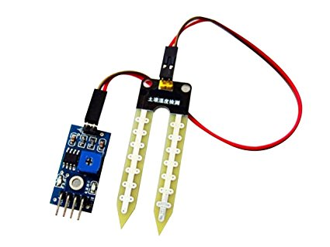

Figure Soil Moisture Sensor

* **Rain Sensor -** This sensor gives data to system either it is raining or not. The rain sensor operates in a rather easier way. The sensing device, which has a sequence of open copper traces, functions as a variable resistor (similar to a potentio-meter) whose resistance changes depending on how much water is on its surface. The amount of surface water has an inverse relationship with resistance: the more water on the surface, the higher the conductivity and the lower the resistance. The less water on the surface, the worse the conductivity and the higher the resistance. The sensors transmit an output voltage based on the resistance, which may be used to assess whether or not it is raining. The user must first provide electricity to the sensor. Users may do this by connecting the module’s VCC pin to the Arduino’s 5V supply. However, one well-known concern with these sensors is that they have a short life when exposed to moisture. Continuously providing electricity to the sensor pad accelerates corrosion dramatically. To avoid this, we recommend that you only power the sensor when taking readings. Connect the VCC pin to a digital pin on an Arduino and adjust it to HIGH or LOW as needed. The total power required by the module (when both LEDs are lighted) is around 8 mA, therefore it’s fine to power it from an Arduino digital pin. So, connect the VCC pin of the module to an Arduino’s digital pin 7 and the GND pin to the ground. Finally, attach the DO pin of the module to Arduino’s digital pin 8.

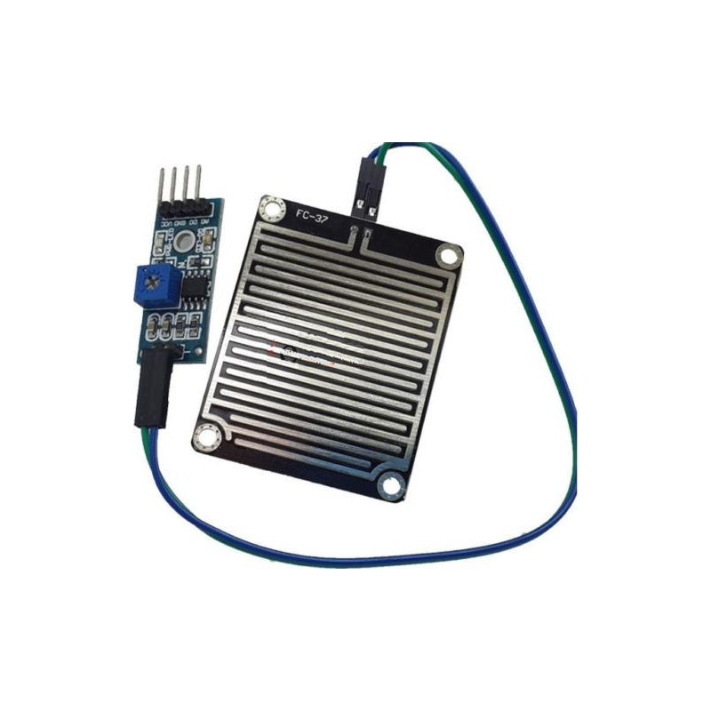

Figure Rain Sensor

* **The NodeMCU 8266 -** NodeMCU is a popular open-source electronics platform, much like Arduino, but with a focus on Internet of Things (IoT) applications. It is based on the ESP8266 microcontroller, which integrates Wi-Fi connectivity, making it ideal for IoT projects that require wireless communication and internet connectivity. NodeMCU provides a simple hardware and software platform for building IoT applications with ease.

Key features and uses of NodeMCU include:

* **ESP8266 Microcontroller**: NodeMCU is powered by the ESP8266 microcontroller, which combines a powerful processor with built-in Wi-Fi capabilities, enabling seamless communication with the internet.
* **Arduino-like Programming**: NodeMCU programming is based on a simplified version of the Lua programming language. It’s easy-to-understand syntax makes it accessible for beginners and experienced developers alike.
* **IoT Connectivity**: NodeMCU's Wi-Fi connectivity allows it to communicate with cloud services, web servers, and other IoT devices. This makes it an excellent choice for building smart home systems, remote monitoring applications, and IoT-enabled automation.
* **Integrated Development Environment (IDE)**: Similar to Arduino, NodeMCU has its own IDE for programming and uploading code to the board. This IDE simplifies the development process and offers a familiar interface for developers accustomed to working with Arduino.
* **Analog and Digital I/O**: NodeMCU features both analog and digital input/output pins, allowing it to interface with a wide range of sensors and actuators.

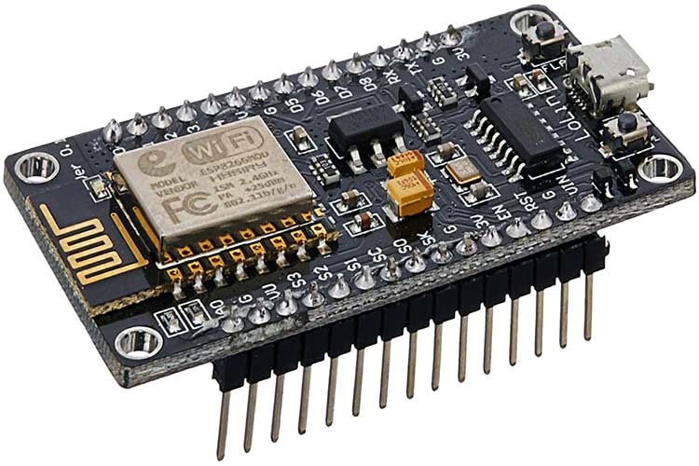

Figure Node MCU 8266

* **Relay (Motors Controller)**: The motors in the system are controlled by the relay module. The relay module is an electrically driven switch that enables you to turn on or off a circuit with significantly greater voltage and/or current than a micro-controller can manage. The Arduino is linked to the devices through relay, as indicated in the diagram. The relay may be used as a switch to turn on or off the gadgets in this case. In this project a five-volt relay has been used. It controls the motors by receiving data from the controller. The pump motor works on more than 5 volts, there needs additional power for the motor. here We have been used a 9V DC power supplier for the power of the motor. We can also use AC power.

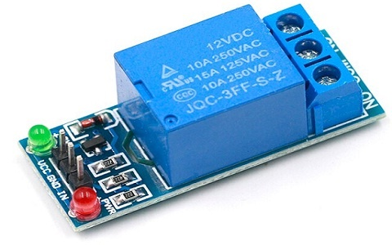

Figure Relay (Motor Controller)

* **Motor Pump**: The water pump used in intelligent agriculture is a major component of current agricultural methods aimed at optimizing water consumption and enhancing crop output. These smart water pumps are meant to be energy-efficient, dependable, and controlled, making them suitable for irrigation systems in precision agriculture. Equipped with sensors and IoT capabilities, the pump may be incorporated into a smart agricultural network, allowing automatic and remotely controlled watering programs.

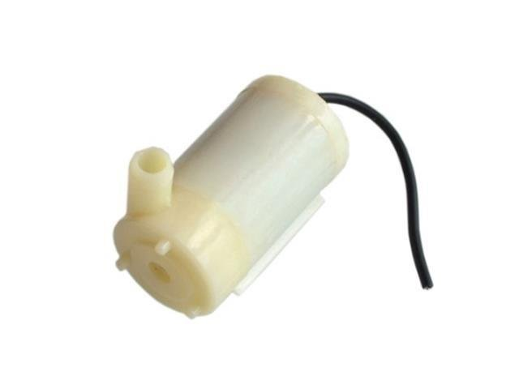

Figure Water Pump

* **Breadboard**: The In electronics, a breadboard is a flexible prototype device that may be used to develop and test circuit designs without the necessity of solder. It is built from of a grid of linked clips or connections that allow it straightforward to plug in and connect electronic devices such resistors, capacitors, and microcontrollers. Breadboards are vital for the design and testing of electrical equipment and sensor networks in the context of smart farming. They provide a simple and rapid platform for connecting and testing a number of smart farming components, including soil moisture sensors, temperature and also humidity sensors, water pumps, and actuators. By utilizing a breadboard, farmers and engineers may experiment with alternative circuit designs and sensor integrations, ensuring that the smart farming system performs effectively and precisely.

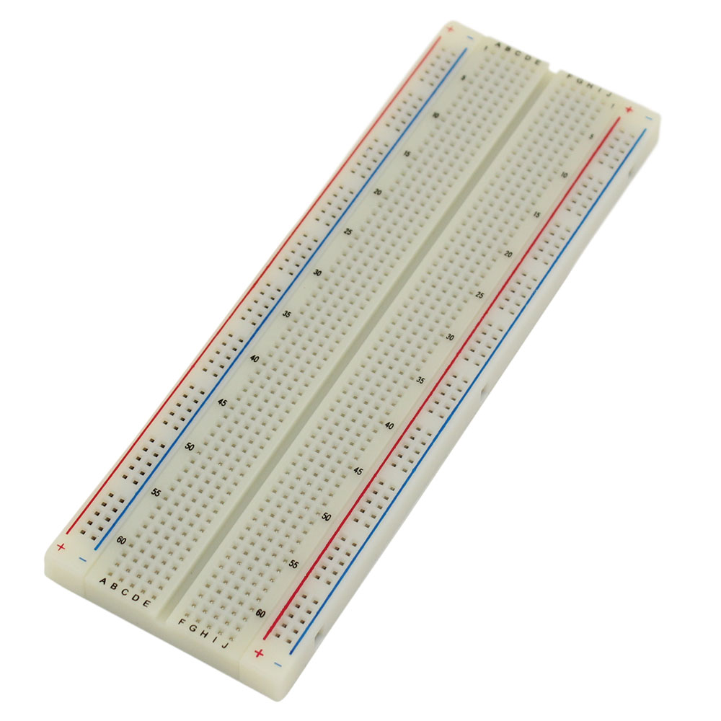

Figure Bread Board

* **9V Battery:** 9V battery is a vital power source for different electrical components and devices employed in agricultural automation and monitoring systems. These batteries, frequently in the form of no rechargeable Li-ion or LiPo batteries, offer a stable and portable energy source to power smart agricultural equipment like as soil moisture sensors, temperature and humidity sensors, wireless communication modules, actuators, and microcontrollers. Due to their small size and high energy density, 9V batteries are well-suited for integration into smart farming installations, enabling the deployment of wireless and remote monitoring systems over broad agricultural areas. With correct power management and effective use, 9V batteries help to improving irrigation systems, automated equipment, and environmental monitoring in smart farming, eventually leading to higher crop production, water conservation, and overall sustainable agricultural practices.

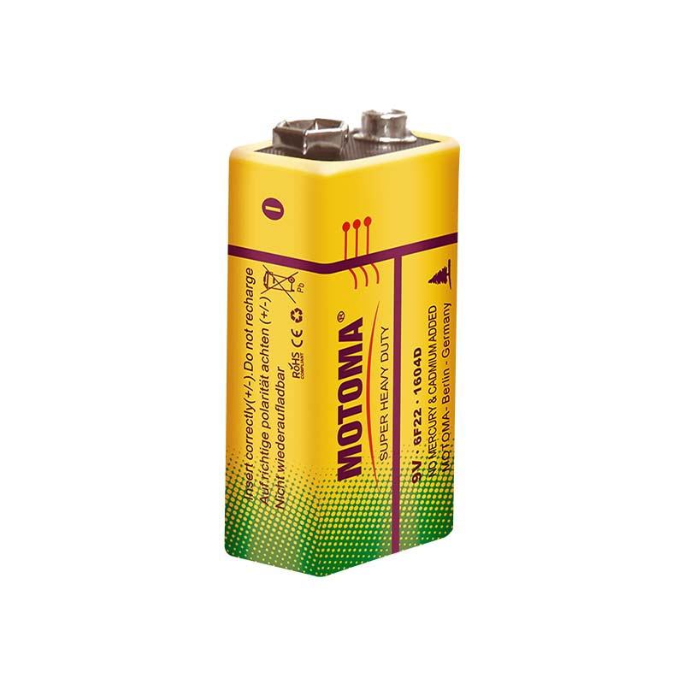

Figure 9V Battery

## Project Overview

To utilize the full IoT-based smart irrigation system, the user has to follow these steps:

1. **Creating an Account on Blynk**: The user has to download the Blynk mobile application or visit the Blynk website to create an account. They will join up using their email address, and following successful registration, they will get their unique Blynk account credentials, including the Auth Token.

2. **Installing Blynk Library**: In the Arduino Integrated Development Environment (IDE), the user will install the Blynk library by clicking to "Sketch" > "Include Library" > "Manage Libraries." They will search for "Blynk" and click "Install" to add the Blynk library to the Arduino IDE.

3. **Obtaining Auth Token**: The user will obtain an Auth Token when they establish an account on Blynk. This token acts as an authentication key for the Arduino device to interact with the Blynk cloud server.

4. **Configuring NodeMCU and Wi-Fi**: In the Arduino IDE, the user will load the example sketch given by the Blynk library, particularly built for NodeMCU (ESP8266). They will update the placeholder values with their Wi-Fi credentials (SSID and password) to allow the NodeMCU to connect to their Wi-Fi network.

5. **Adding Widgets in Blynk App**: Using the Blynk app, the user will create a new project and add widgets such as buttons, sliders, gauges, and graphs to the project dashboard. These widgets will serve as controls and indications to interact with the smart irrigation system.

6. **Programming NodeMCU**: The user will alter the sample sketch code for NodeMCU to incorporate the Auth Token received from the Blynk account. They will also setup the GPIO pins attached to the sensors and actuators in the code.

7. **Establishing Connection**: The user will upload the changed sketch to the NodeMCU board using a USB cord. Once the code is successfully uploaded, the NodeMCU will start operating the smart watering system. It will create a connection to the Wi-Fi network and the Blynk cloud server using the Auth Token.

8. **Configuring Widgets and Functionality**: In the Blynk app, the user will attach each widget to the proper virtual pin on the NodeMCU. For example, they may attach a button widget to the virtual pin that controls the water pump. They will also select the required thresholds for soil moisture levels and design the system's reaction accordingly.

9. **Monitoring and Controlling**: With the NodeMCU linked to Blynk, the user can now remotely monitor the soil moisture levels, rain data, and other sensor readings on the Blynk app's dashboard. They may also regulate the irrigation process by turning the water pump on or off using the app's widgets.

10. **Data Analysis and Feedback**: The Blynk app will continually receive data from the NodeMCU, offering real-time insights into the tea garden's watering status. The user may examine this data to improve irrigation schedules, save water, and boost crop output.

By following these procedures, the user may successfully utilize the complete IoT-based smart irrigation system, taking use of Blynk's user-friendly interface to remotely manage and monitor the watering process for their tea garden.

# Implementation

For implementation I uses many hard-wares and soft-wares. The hardware included a controller boar, many sensors, breadboard, motor, relays, LED, jumping wire etc. The implementation images of this system have been added in the appendix individually.



Figure 4: Irrigation Control System Implementation.

## Hardware

1. Node MCU 8266 (afsfasfasf 2009)
2. Moisture Sensor
3. Water level Sensor
4. Rain Sensor
5. Relays and motor
6. WIFI SIM800 Module
7. DC Battery and Jumping wires.

## Software and Code

For the system code , Arduino IDE has been used.Besides Microsoft Powerpoint used for drawing various flowchart and diagrams etc.The Arduino IDE is free software that allows you to create and find the attached Arduino boards. The IDE program is compatible with

Windows, Mac OS X, and Linux. The application programs C and C++ are supported. IDE refers to the Integrated Development Environment. Sketching refers to the software or code written in the Arduino IDE. To upload the program generated in the Arduino IDE software, we must link the Usually derived Arduino board to the IDE. The extension ’.ino’ is used to save the drawing.The code for this system has been added in appendix.

### Online Cloud Server(ThingSpeak)

ThingSpeak is an open platform as a service and API for such Internet of Things that lets you gather, store, analyze, display, and act on sensor data.ThingSpeak is an Internet of the Things application platform. ThingSpeak allows users to create an application based on sensor data. Real-time data gathering, data processing, visualizations, applications, and plugins are among the features of ThingSpeak.A ThingSpeak Channel is the basis of

ThingSpeak. You submit your information to be preserved over a channel. Each channel has eight data fields, three location fields, and one status field. Once you’ve created a ThingSpeak Channel, you may publish data to it, have it processed by ThingSpeak, just to have your application get it.

# Result

Our system has multiple hardware components ,they are arduino (the system controller) , Soil moisture sensor, Rain sensor, temperature sensor, WiFi module and relays. Sensors collects data and sends these data to Thingspeak IOT cloud via WiFi module. The moisture sensor senses the soil moisture of the field. The collecting data from the sensors after implementation are giver bellow.

The manual output value in the serial monitor-

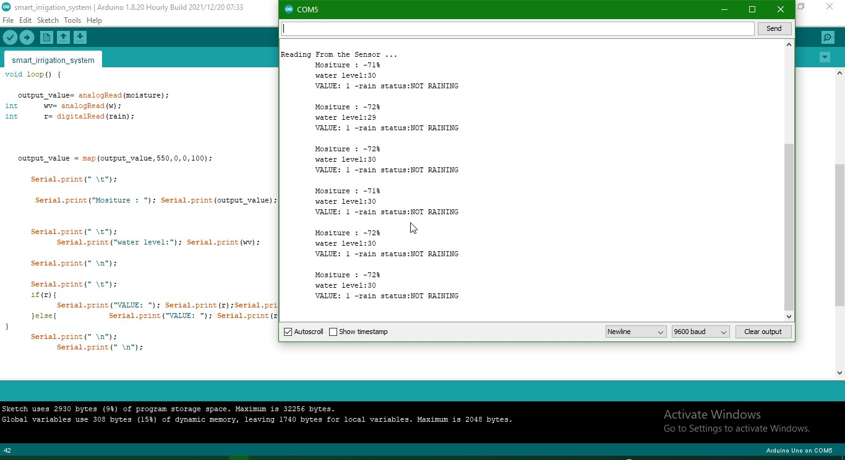

Figure 5: The Output in The serial monitor in Arduino IDE.

The system collects various data from the

field like soil moisture, Humidity,temperature and water level etc. the system sends the data cloud server thingspeak over WIFI module. Here we makes collected data graph from the collected data individually.

The temperature and humidity graph showing bellow-

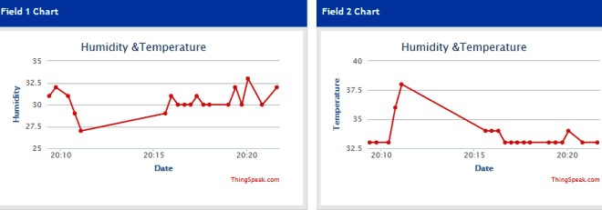

Figure 6: The collected data Graph (temperature and humidity).

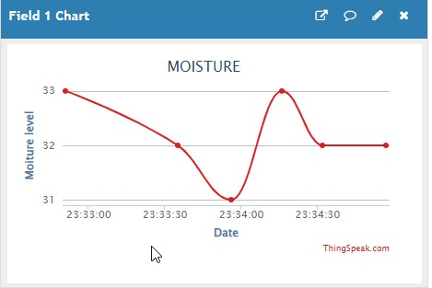

Figure 7: The collected data Graph (temperature and humidity).

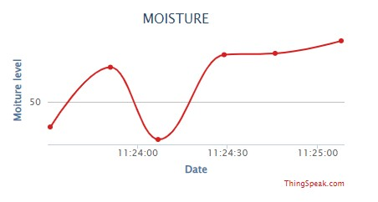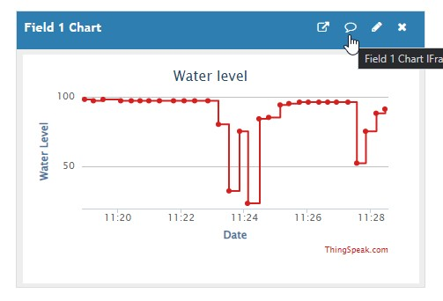

Figure 8: The collected data Graph (Moisture).

Figure 9: The collected data Graph (Water level).

# Expected Result

Ours is a fully automated system. It is based on information gathered in the field. Multiple sensors monitor the water level and moisture temperature, and the system collects this information and compares it to the standard necessary level. The pump or motors will be turned on or off automatically once the data has been analyzed. As a result, there is no room for excessive water consumption. It is possible to save money by lowering the amount of water used. It takes fewer manpower since it is an automated system. It also saves money, time, and effort. There are also some challenges that our system may be faced. IOT is complex network to implement.Sensors are temporary they would be damaged frequently.It may consume high cost.Unskilled farmers in our country do not much about our system etc .

# Conclusion

The smart irrigation system is suited and cost-effective for enhanced water resources for agricultural production. A feedback control system would be included in the system, which would efficiently monitor and manage all plant growth and irrigation system operations. When it rains, flooding might be prevented if a rain gun sensor could be installed. It is feasible to collect rainwater, which may then be used to irrigate crops. We may also include a lot more water quality sensors that affect the crops.In future , different machine learning would be included, which will make our system more efficient and stable, accurate . We will use more different sensors also.

**References**

1. R. N. Rao and B. Sridhar, “Iot based smart crop-field monitoring and automation irrigation system,” in *2018 2nd International Conference on Inventive Systems and Control (ICISC)*, pp. 478–483, IEEE, 2018.
2. S. Rawal, “Iot based smart irrigation system,” *International Journal of Computer Applications*, vol. 159, no. 8, pp. 7–11, 2017.
3. M. N. Rajkumar, S. Abinaya, and V. V. Kumar, “Intelligent irrigation system—an iot based approach,” in *2017 International Conference on Innovations in Green Energy and Healthcare Technologies (IGEHT)*, pp. 1–5, IEEE, 2017.
4. D. Mishra, A. Khan, R. Tiwari, and S. Upadhay, “Automated irrigation system-iot based approach,” in *2018 3rd International conference on internet of things: Smart Innovation and Usages (IoT-SIU)*, pp. 1–4, IEEE, 2018.
5. S. B. Saraf and D. H. Gawali, “Iot based smart irrigation monitoring and controlling system,” in *2017 2nd IEEE International Conference on Recent Trends in Electronics, Information & Communication Technology (RTEICT)*, pp. 815–819, IEEE, 2017.
6. A. Imteaj, T. Rahman, M. K. Hossain, and S. Zaman, “Iot based autonomous percipient irrigation system using raspberry pi,” in *2016 19th International Conference on Computer and Information Technology (ICCIT)*, pp. 563–568, IEEE, 2016.

**Appendix**

# A

## Code

The code for this system is given here.

#include <SoftwareSerial.h>

SoftwareSerial espSerial(2, 3);

#define DEBUG true

String mySSID = "mi3";

String myPWD = "*******";

String myAPI = "BI7MPDRL2U7DYTC1"; String myHOST = "api.thingspeak.com";

String myPORT = "80";

String myFIELD1 = "field1";

String myFIELD11 = "field2";

String myFIELD = "field3"; #define motorPower 8 int moisture= A0; int w = A1; int rain = A3; int output_value ;

int sendVal;

void setup()

{

pinMode(motorPower,OUTPUT);

Serial.begin(9600); espSerial.begin(115200);

espData("AT+RST", 1000, DEBUG); espData("AT+CWMODE=1", 1000, DEBUG);

espData("AT+CWJAP=\""+ mySSID +"\",\""+ myPWD +"\"", 1000, DEBUG); delay(1000);

}

void loop()

{

output_value= analogRead(moisture); int wv= analogRead(w); int r= digitalRead(rain);

output_value = map(output_value,550,0,0,100); sendVal = output_value;

String sendData = "GET /update?api_key="+ myAPI +"&"+ myFIELD1

+"="+String(sendVal) +"&"+ myFIELD2+"="+String(wv) +"&"+ myFIELD3 +"="+String(r);

espData("AT+CIPMUX=1", 1000, DEBUG);

espData("AT+CIPSTART=0,\"TCP\",\""+ myHOST +"\","+ myPORT, 1000, DEBUG);

espData("AT+CIPSEND=0," +String(sendData.length()+4),1000,DEBUG); espSerial.find(">"); espSerial.println(sendData);

Serial.print("Value to be sent: ");

Serial.println(sendVal);

espData("AT+CIPCLOSE=0",1000,DEBUG); delay(10000);

}

String espData(String command, const int timeout, boolean debug)

{

Serial.print("AT Command ==> ");

Serial.print(command);

Serial.println(" ");

String response = ""; espSerial.println(command); long int time = millis(); while ( (time + timeout) > millis())

{

while (espSerial.available())

{

char c = espSerial.read(); response += c;

}

}

if (debug)

{

Serial.print(response);

}

return response;

if(output_value<=10){

if(r == 0){

digitalWrite(motorPower,HIGH); delay(3000);

}

else{ if (wv <= 400){ digitalWrite(motorPower,LOW);

} else {

digitalWrite(motorPower,HIGH);

}

}

Text of Appendix A is Here

# B

## Implementation images

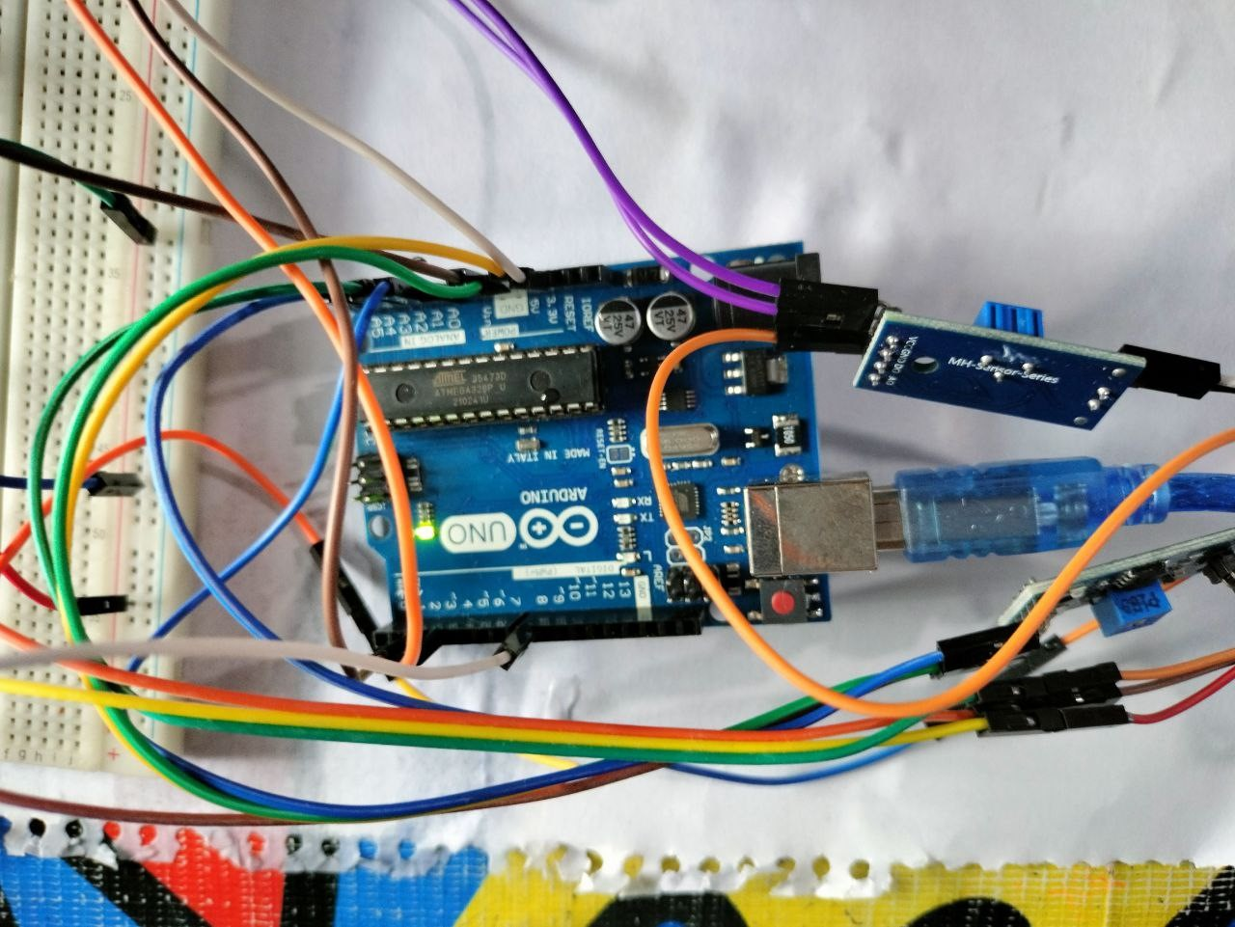

Figure 10: Main Controller

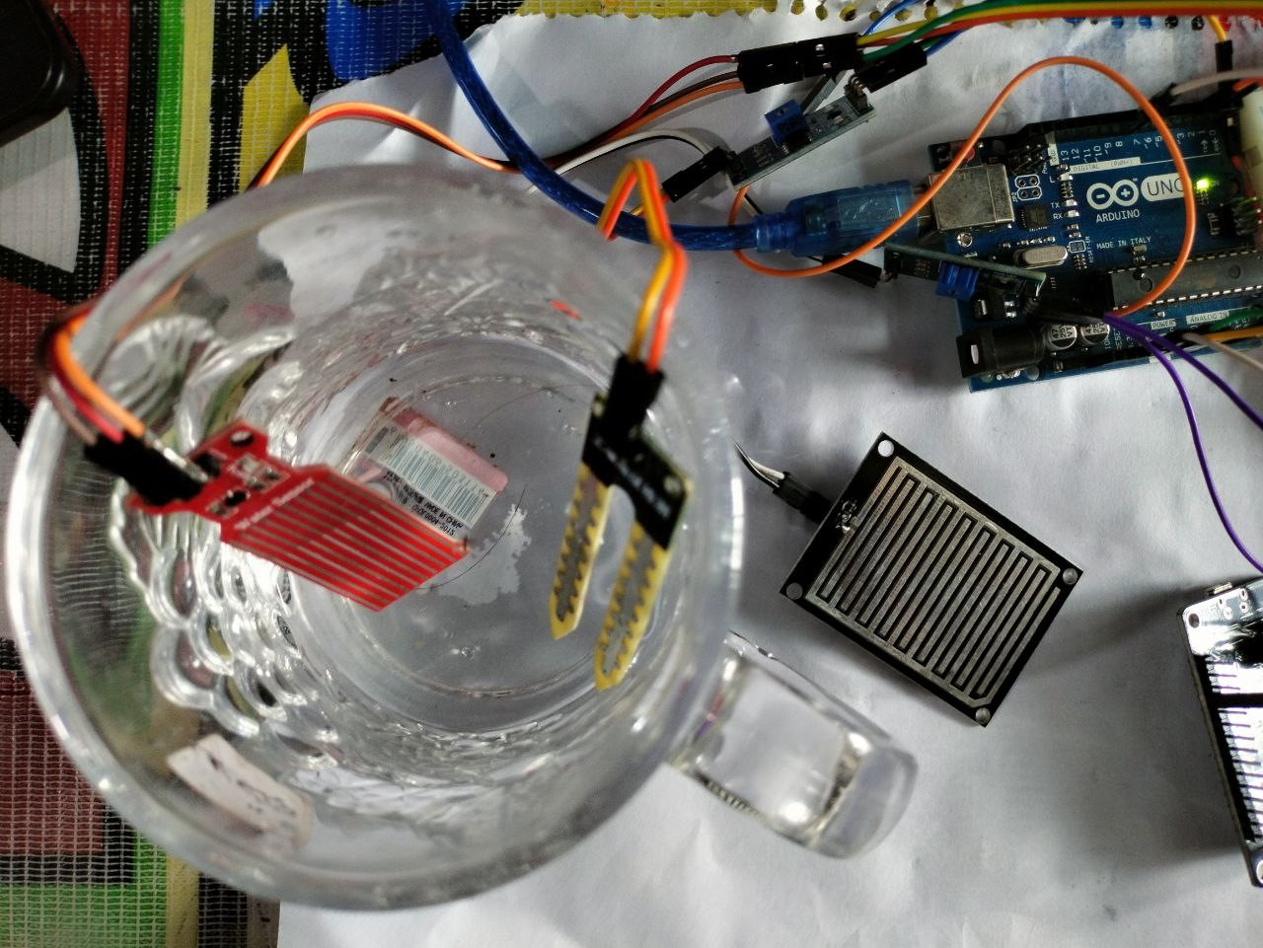

Figure 11: sensors

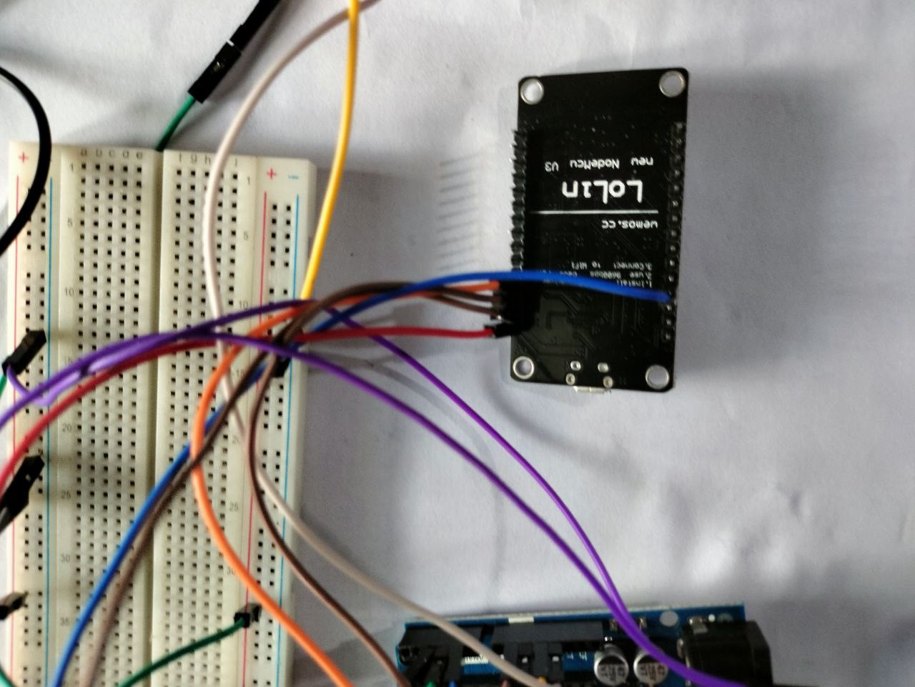

Figure 12: WiFi Module

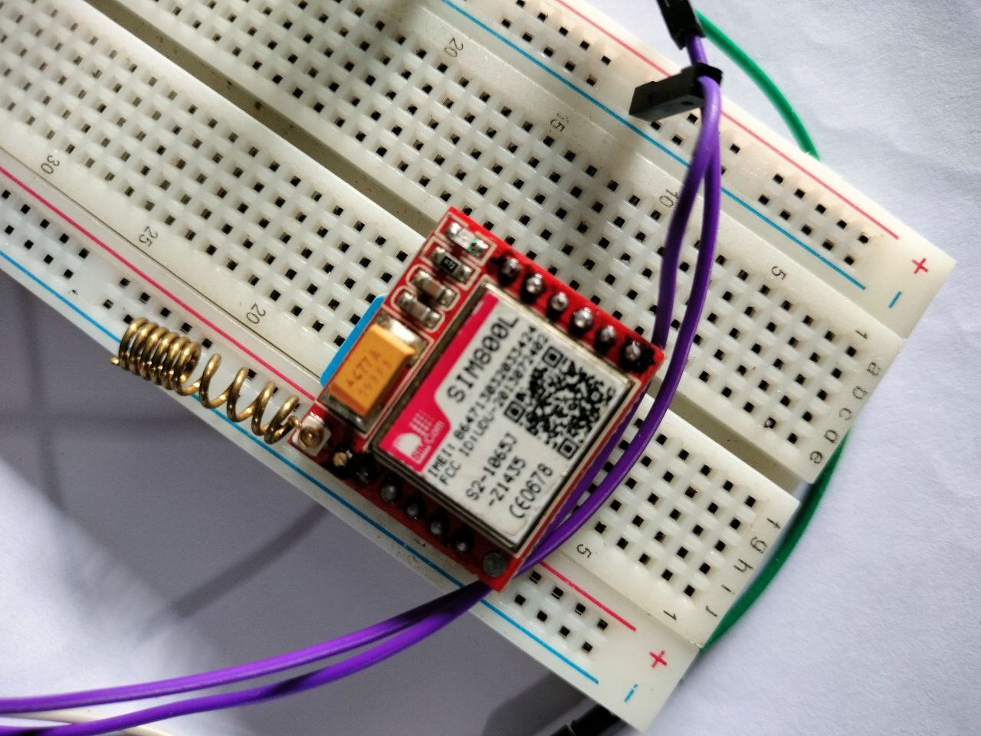

Figure 13: WIFI SIM800 Module

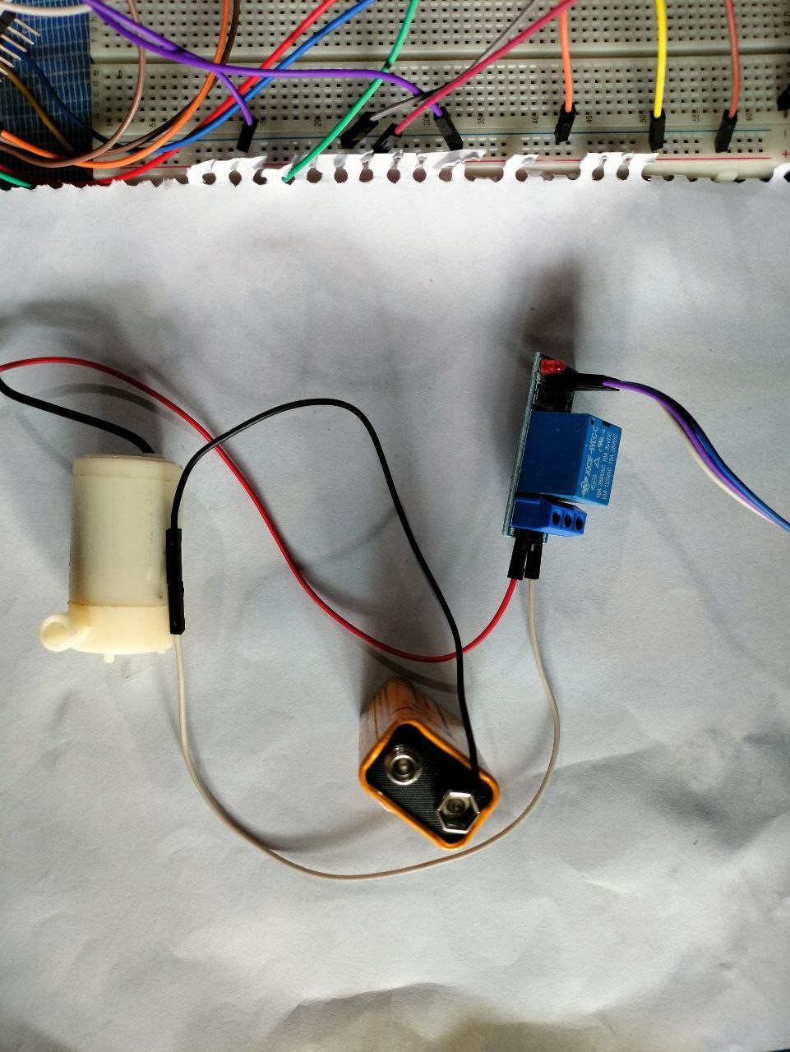

Figure 14: motor and relay